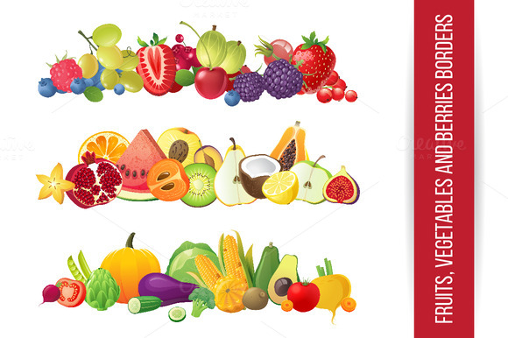
MENU

Monday | Tuesday | Wednesday | Thursday | Friday
15th | 16th | 17th | 18th | 19th
Pasta/Cheese & Tomato Sauce  Salad  Wholemeal Bread | Roast Beef  Roast Potatoes  Green Beans | Chicken Breast  Jacket Wedge  Salad  Coleslaw | Salmon Nuggets  New Potatoes  Baked Beans | Beef Burger  Wholemeal Bun  Finger Salad
Fresh Strawberries  Ice Cream | Yoghurt  Oaty Biscuit | Jam Sponge  Custard | Fresh Fruit | Chocolate Krispy Cake
Monday | Tuesday | Wednesday | Thursday | Friday
22nd | 23rd | 24th | 25th | 26th
Crispy Cod  Chips  Garden Peas | Macaroni Cheese  Wholemeal Stick  Salad | Chicken Curry  Basmati Rice  Naan Bread | Roast Pork  Stuffing  Roast Potatoes  Sliced Carrots | Hot Dog  Wholemeal Roll  Finger Salad
Artic Roll  Peach Slices | Fresh Fruit | Cherry Crumble  Custard | Yoghurt  Fruit | Chocolate Chip Cookies

