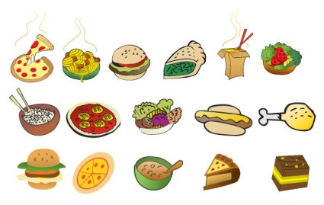
Monday | Tuesday | Wednesday | Thursday | Friday
16th | 17th | 18th | 19th | 20th
Pasta with Rustic Tomato Sauce  Grated Cheese  Wholemeal French Stick  Seasonal Salad | Roast Pork  Stuffing  Roast Potatoes  Fresh Steamed Carrots | Salmon Fingers  New Potatoes  Baked Beans | Wholemeal Breaded Chicken  Potato Wedges  Coleslaw  Seasonal Salad | Beef Burger  Wholemeal Roll  Finger Salad
Rice Pudding | Mixed Fruit  Sorbet | Yoghurt  Oaty Biscuit | Fresh Fruit | Choc Chip Cookie  Fruit Smoothie
Monday | Tuesday | Wednesday | Thursday | Friday
23rd | 24th | 25th | 26th | 27th
Pasta  Bolognaise Sauce  Carrot Slaw | Tuna/Egg  Salad  Sauté Potatoes | Hot Dog  Wholemeal Roll  Finger Salad | Chicken Curry  Boiled Rice | Cod Fillet  New Potatoes  Garden Peas
Pears  Hot Chocolate Sauce | Fresh Fruit | Yoghurt  Biscuit | Melon & Strawberries | Raspberry Buns
MENU

