MENU

Monday | Tuesday | Wednesday | Thursday | Friday
23rd | 24th | 25th | 26th | 27th
Fish Fingers  Chips  Beans | Chicken Curry  Rice  Naan Bread | Pasta, Tomato & Cheese Sauce  Wholemeal Crusty Bread | Herbie Lamb Cobbler  Mashed Potato  Green Beans | Choice of Soup & Sandwiches
Raspberry Artic Roll  Peaches | Yoghurt  Shortbread | Cherry Crumble  Custard | Fresh Fruit | Chocolate Rice Crispy Cake
Monday | Tuesday | Wednesday | Thursday | Friday
2nd | 3rd | 4th | 5th | 6th
Pasta Bolognaise  Served with Carrot Slaw | Cod Fillet in Breadcrumbs  New Potatoes  Baked Beans | Roast Pork  Sliced Carrots  Stuffing & Apple | Breaded Chicken Breast  Potato Wedges  Salad  Coleslaw | Hot Dog Sausages  Wholemeal Roll  Finger Salad
Pineapple Upside Down Cake  Custard | Yoghurt  & Oaty Biscuit | Cheese &  Biscuits | Strawberry Eton Mess  Coulis | Oaty Fruit Cookie
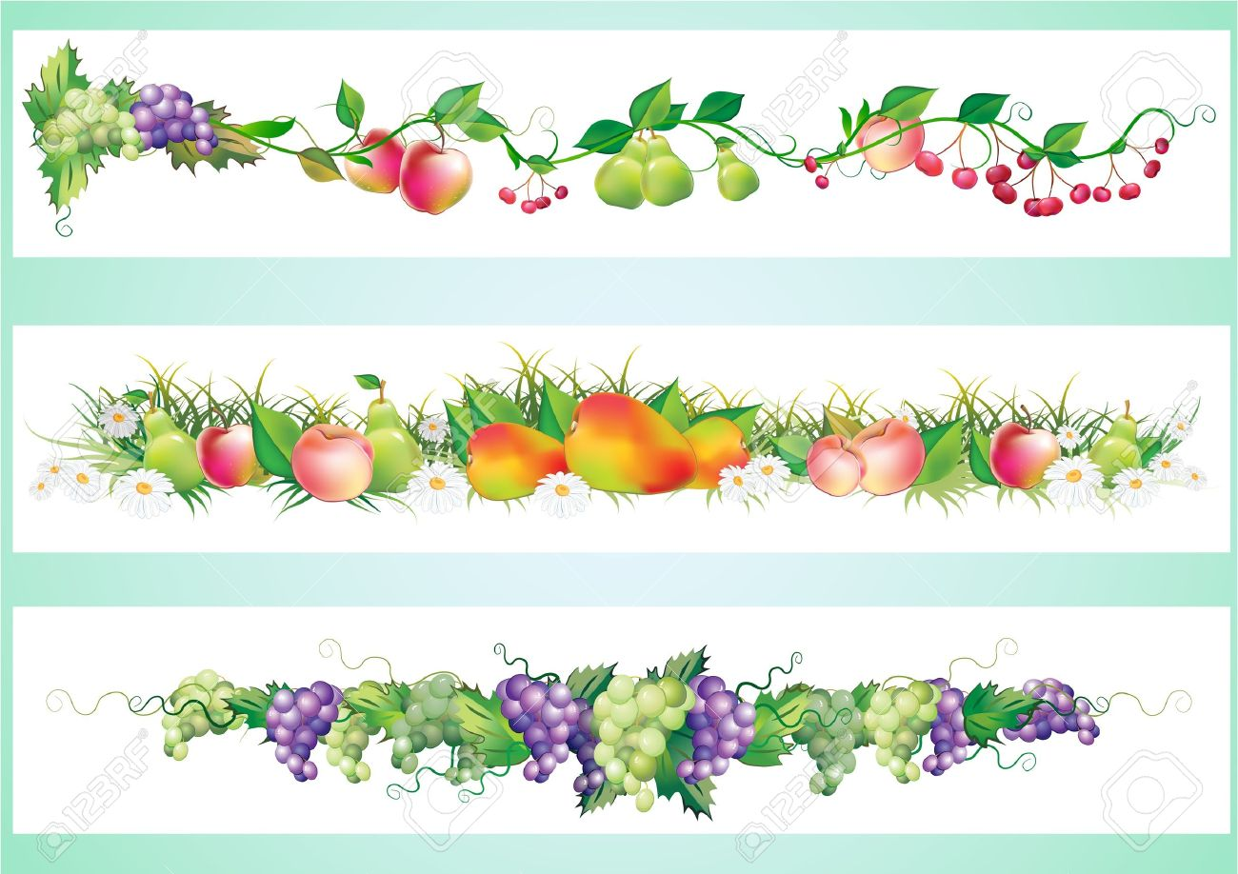
FOR ANY INFORMATION REGARDING FOOD ALLERGIES & INTOLERENCES PLEASE SPEAK TO A MEMBER OF WPS STAFF

