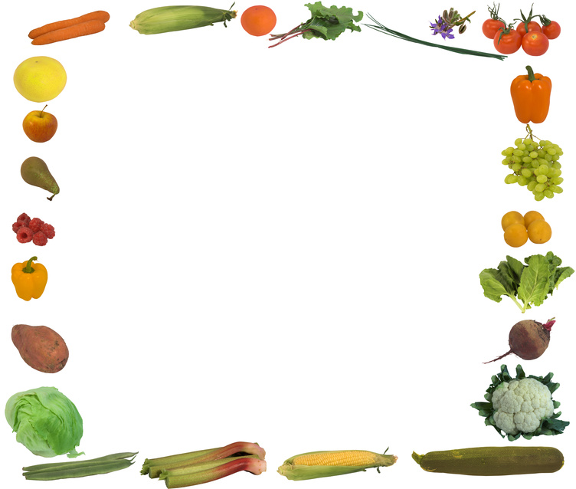
MENU

Monday | Tuesday | Wednesday | Thursday | Friday
24th | 25th | 26th | 27th | 28th
Chicken & Vegetable Pie  With Shortcrust Pastry  Peas | Pork Ragu Pasta  Garlic Bread  & Carrot Slaw | Salmon Nuggets  New Potatoes  Beans | Roast Beef  Yorkshire Pudding  Roast Potatoes  Green Beans | Choice of Soup  Selection of Sandwiches
Fresh Fruit | Mixed Fruit & Raspberry Sorbet | Rice Pudding | Yoghurt with  Oaty Biscuit | Rice Crispy Cake
Monday | Tuesday | Wednesday | Thursday | Friday
1st | 2nd | 3rd | 4th | 5th
Toad in the Hole  Mashed Potatoes  Gravy  Garden Peas | Gammon  Sauté Potatoes  Cauliflower Cheese | Breaded Chicken with Pasta & Tomato Sauce  Seasonal Salad | Cod Fishcake  Pomme Noisettes  Baked Beans | Beef Burger  Wholemeal Roll  Finger Salad
Sliced Mandarin Orange  Chocolate Ice Cream | Yoghurt with  Oaty Biscuit | Fresh Fruit | Pears with  Hot Chocolate Sauce | Raspberry Buns

