MENU

Monday | Tuesday | Wednesday | Thursday | Friday
2nd | 3rd | 4th | 5th | 6th
Tuna, Egg, Ham  Salad  New Potatoes | Chicken & Sweetcorn Puff Pastry Pie  Sauté potatoes  Garden Peas | Roast Beef  Yorkshire Pudding  Roast Potatoes  Sliced Green Beans | Chicken Breast  Pasta & Tomato Sauce  Seasonal Salad | Beef Burger  Wholemeal Roll  Finger Salad
Rice Pudding | Mixed Fruit  Ice cream | Fresh Fruit | Yoghurt  Biscuit | Iced Finger
Monday | Tuesday | Wednesday | Thursday | Friday
9th | 10th | 11th | 12th | 13th
Salmon Fishcakes  New Potatoes  Beans | Homemade Meatballs  Pasta & Tomato Sauce | Roast Ham  Sauté Potatoes  Cauliflower Cheese | Chicken Burger  Salad  Coleslaw | Picnic Lunch
Warm Chocolate Brownie  Vanilla Ice Cream | Fresh Fruit | Yoghurt  Oaty Biscuit | Fruit Jelly | Choc Chip Cookie  Fruit Smoothie
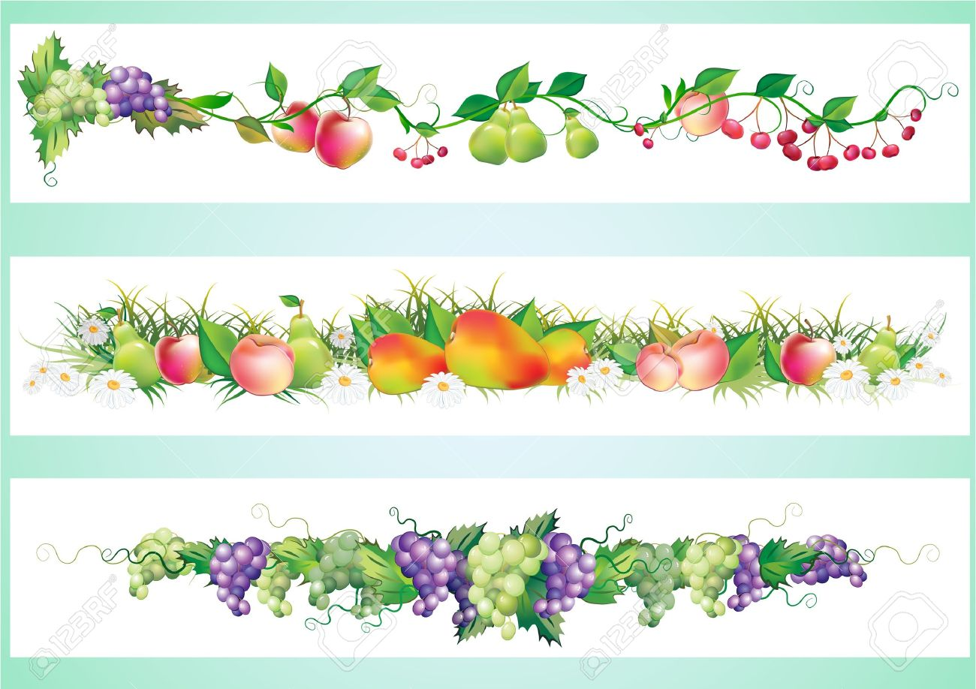
FOR ANY INFORMATION REGARDING FOOD ALLERGIES & INTOLERENCES PLEASE SPEAK TO A MEMBER OF WPS STAFF

