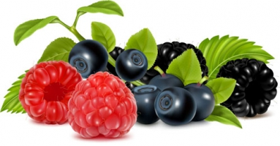
MENU

Monday | Tuesday | Wednesday | Thursday | Friday
2nd | 3rd | 4th | 5th | 6th
Chicken Curry  Boiled Rice  Naan Bread | Cod Fishcake  Saute Potatoes  Garden Peas | Herby Minced Lamb Cobbler  Roasted New Potatoes  Steamed Broccoli | Bangers!!!!  Creamy Mash  Whizzy Bang Beans   | Assortment of Sandwiches  Choice of Soup
Cheese & Biscuits  Apple Slices | Yoghurt  Oaty Biscuit | Seasonal Fresh Fruit | Treacle Sponge  Custard | Fruity Flapjack
Monday | Tuesday | Wednesday | Thursday
9th | 10th | 11th | 12th
Chilli & Rice  Garlic Bread | Wholemeal Breaded Chicken Breast  Pasta with Rustic Tomato Sauce  Seasonal Salad | Roast Beef  Yorkshire Pudding  Roast Potatoes  Sliced Green Beans  Gravy | Wilmslow Prep Brunch
Yoghurt  Fruit Compot | Fruit Jelly | Banana Custard | Chocolate Sponge  Vanilla Ice Cream
Friday
13th

Salmon Fillet
New Potatoes
Petit Pois

Pudsey Buns

