MENU

Monday | Tuesday | Wednesday | Thursday | Friday
 | 6th | 7th | 8th | 9th
 | Jacket Potato  Choice of fillings  Seasonal Salad | Minced Beef & Onion Pie  Sauté Potatoes  Peas | Roast Pork  Roasted New Potatoes  Carrots  Stuffing &  Apple Sauce | Chicken Curry  Rice  Naan Bread
 | Fresh Fruit | Yoghurt  Shortbread | Jam Sponge  & Custard | Chocolate Rice Crispy Cakes
Monday | Tuesday | Wednesday | Thursday | Friday
12th | 13th | 14th | 15th | 16th
Salmon Fishcakes  New Potatoes  Peas | Chilli & Rice  Garlic Bread  Carrot Slaw | Shepherd’s Pie  Carrots | Roast Beef  Roast Potatoes  Yorkshire Pudding  Gravy | Hot Dog Roll  Finger Salad
Yoghurt  Oaty Biscuit | Banana Custard | Fresh Fruit | Chocolate Sponge  Ice Cream | Homemade Flapjack
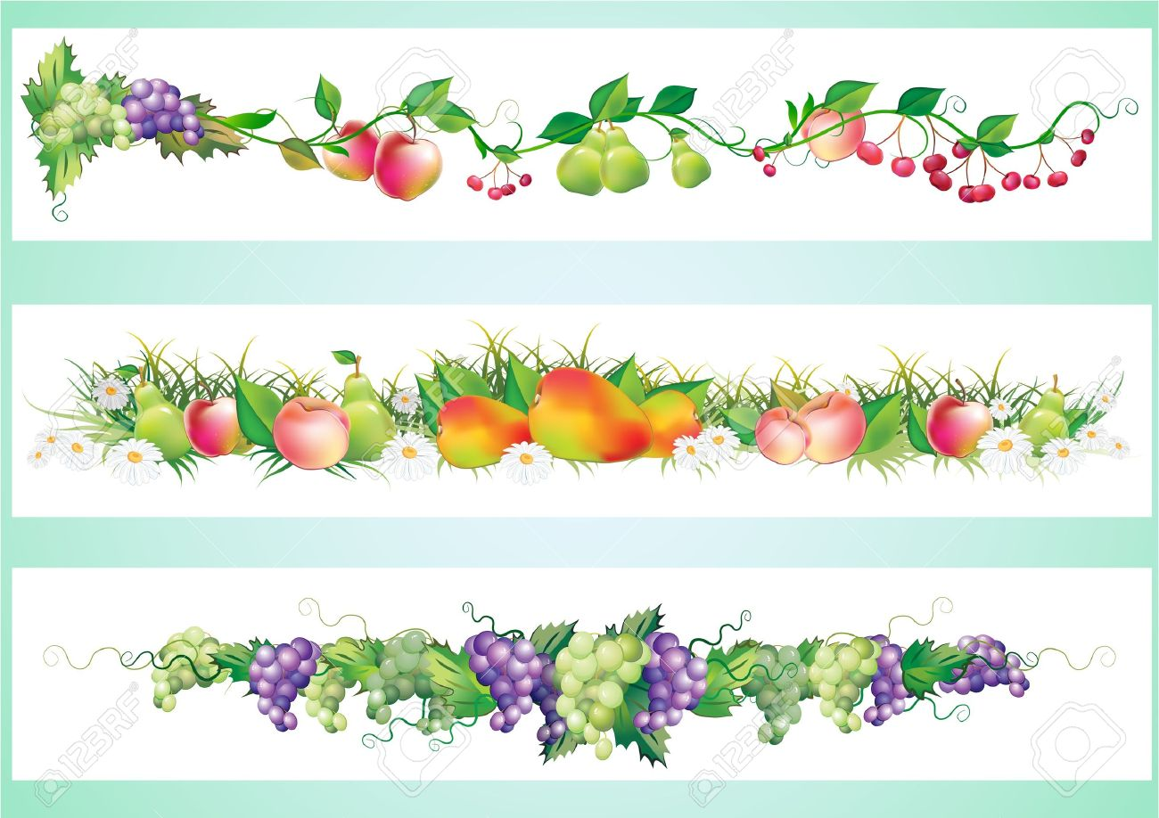
FOR ANY INFORMATION REGARDING FOOD ALLERGIES & INTOLERENCES PLEASE SPEAK TO A MEMBER OF WPS STAFF

