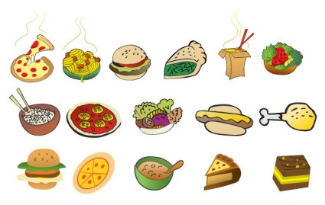
Monday | Tuesday | Wednesday | Thursday | Friday
4th | 5th | 6th | 7th | 8th
School Closed | INSET Day | Wholemeal Breaded Chicken  Pasta & Rustic Tomato Sauce  Side Salad | Roast Beef  Roast Potatoes  Yorkshire Pudding  Sliced Carrots  Gravy | Cod Fishcake  Saute Potatoes  Baked Beans
 |  | Yoghurt &  Oaty Biscuit | Fresh Fruit | Raspberry Buns
Monday | Tuesday | Wednesday | Thursday | Friday
11th | 12th | 13th | 14th | 15th
Chicken Curry  Rice  Naan Bread | Roast Pork  Stuffing  Roast New Potatoes  Steamed Green Beans | Macaroni Cheese  Wholemeal CrustyBread | Cod Fishfingers  Chips  Baked Beans | Soup  Selection of Sandwiches
Cheese & Biscuits  Apple Slices | Arctic Roll  Peaches | Fresh Fruit | Cherry Crumble  Custard | Iced fairy Cakes
MENU

