MENU

Monday | Tuesday | Wednesday | Thursday | Friday
9th | 10th | 11th | 12th | 13th
Macaroni Cheese  Wholemeal French Stick  Seasonal Salad | Salmon Nuggets  New Potatoes  Peas | Cottage Pie  Sliced Carrots | Wilmslow Prep Brunch | Beef Burger  Wholemeal Roll  Finger Salad
Yoghurt &  Shortbread | Mixed Fruit  Raspberry Sorbet | Fresh Fruit | Pears &  Hot Chocolate Sauce | Homemade Red Nose Buns
Monday | Tuesday | Wednesday | Thursday | Friday
16th | 17th | 18th | 19th | 20th
Chilli con Carne  Rice  Garlic Bread | Cod Fishcake  New Potatoes  Garden Peas | Jacket Potatoes  Beans, Cheese & Tuna  Salad | Roast Beef  Yorkshire Pudding  Roast Potatoes  Broccoli  Gravy | Crispy Chicken  Tortillas  Lettuce, Tomato and Mayonnaise
Chocolate Sponge  Vanilla Ice Cream | Yoghurt &  Biscuit | Fresh Melon  Raspberry Sorbet | Yoghurt &  Biscuit | Fresh Fruit
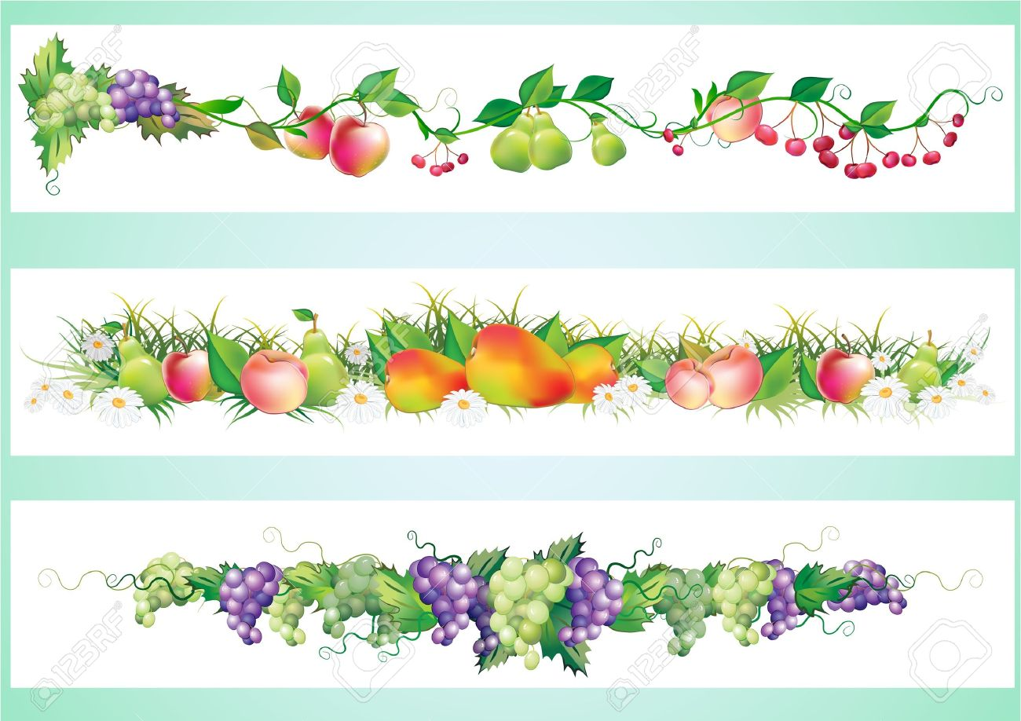
FOR ANY INFORMATION REGARDING FOOD ALLERGIES & INTOLERENCES PLEASE SPEAK TO A MEMBER OF WPS STAFF

