MENU

Monday | Tuesday | Wednesday | Thursday | Friday
19th | 20th | 21st | 22nd | 23rd
Macaroni Cheese  Crusty Wholemeal French stick  Salad | Breaded Chicken  Potato Wedges  Salad & Cream Coleslaw | Wilmslow Prep Brunch | Braised Beef & Vegetable Pie  Sauté Potatoes  Green Beans | Salmon Nuggets  New Potatoes  Garden Peas
Mixed Fruit  Raspberry Sorbet | Choc Chip Sponge  Custard | Yoghurt  Digestive Biscuit | Fresh Fruit | Homemade Raspberry Buns
Monday | Tuesday | Wednesday | Thursday | Friday
26th | 27th | 28th | 29th | 30th
Pasta Bolognaise  Carrot Slaw | Crispy Cod  French Fries  Baked Beans | Roast Lamb  Roasted New Potatoes  Sliced Carrots  Gravy | Toad in the Hole  Mashed Potatoes  Garden Peas | Assortment of Sandwiches  Bowl of Soup
Sliced Peaches  Raspberry Artic Roll | Fresh Fruit | Yoghurt  Shortbread | Rice Pudding | Choc Chip Cookie  Fruit Smoothie
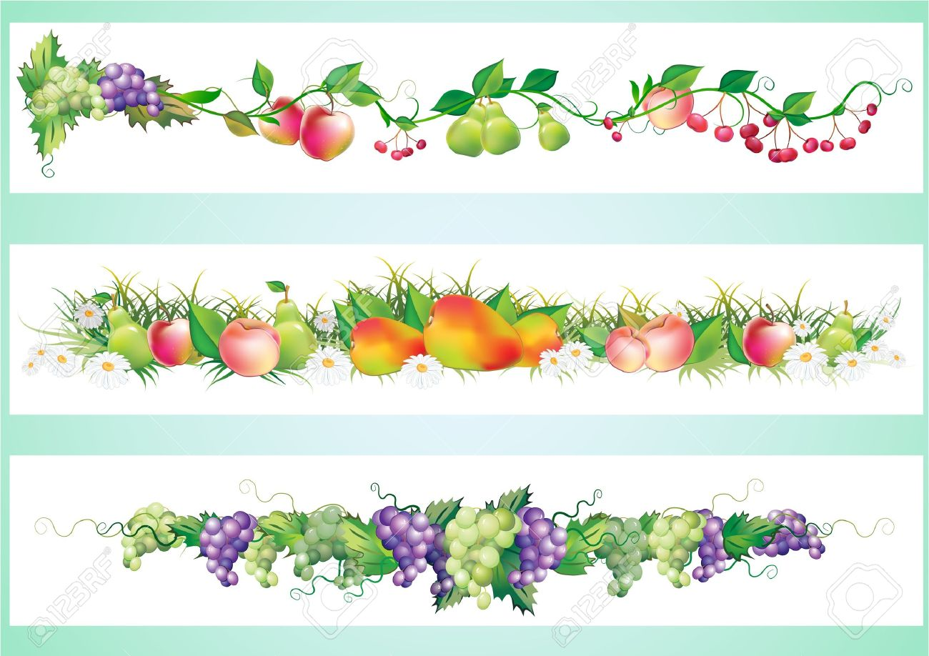
FOR ANY INFORMATION REGARDING FOOD ALLERGIES & INTOLERENCES PLEASE SPEAK TO A MEMBER OF WPS STAFF

