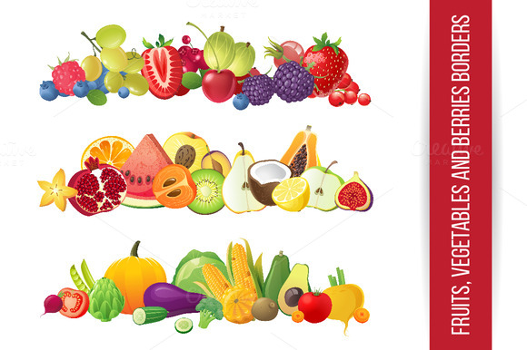
MENU

Monday | Tuesday | Wednesday | Thursday | Friday
1st | 2nd | 3rd | 4th | 5th
Chicken Breast  Pasta & Tomato Sauce  Salad Garnish | Fillet Of Cod  New Potatoes  Garden Peas | Roast Pork  Roast Potatoes  Carrots  Stuffing | Chilli con Carne  Rice  Garlic Bread | Assortment of Fresh Wholemeal Sandwiches  Homemade Soup
Fresh Fruit | Strawberries  Cream | Yoghurt  Oaty Biscuit | Apple & Raisin Cups | Fruit  Flapjack
Monday | Tuesday | Wednesday | Thursday | Friday
8th | 9th | 10th | 11th | 12th
Sliced Ham, Tuna & Egg Salad  Sauté Potatoes | Minced Beef & Onion Pie  Mashed Potatoes  Peas & Sweetcorn | Salmon Fishcake  New Potatoes  Petit Pois | Wilmslow Prep Brunch | Chicken Burger  Wholemeal Bun  Homemade Coleslaw  Finger Salad
Yoghurt | Fresh Fruit | Warm Chocolate Brownies  Ice Cream | Banana Custard | Homemade Pirate Buns
FOR ANY INFORMATION REGARDING FOOD ALLERGIES & INTOLERENCES PLEASE SPEAK TO A MEMBER OF WPS STAFF

